**CHAPTER-1**

**INTRODUCTION**

***1.1   ABOUT THE PROJECT***

Online exam system is very essential for taking exam of students at occasions. Weather it is entrance exam or some aptitude exam of placement in a company, online mode of exam is preferred. Online exam can save lot of resources used in pen and paper exams like paper, ink, etc. It is quicker to create tests once platform for exam creation has been established. Projects such as these serve a great purpose in conducting exams.

In this project admin user is created which can create new questions and new test papers for users to choose from. Admin can create or delete any number of questions and test papers. He can also change his password. Users can access their accounts though their passwords which they can later change after logging into their account. They can view and attempt test papers created by admin in different subjects. After submitting answers user can see how many

This project would be very useful for educational institutes where regular evaluation of students’ is required. Further it can also be useful for anyone who requires feedback based on objective type responses.

Through this project Responses by the candidates will be checked automatically and instantly. Online examination will reduce the hectic job of assessing the answers given by the candidates.

**CHAPTER-2**

**SOFTWARE REQUIREMENTS SPECIFICATION**

***2.1 Hardware Used***

**2.1.1 Client Side:**

**Processor:** core 2duo

**RAM:** 2GB

**2.1.2 Server Side:**

**Processor:** core 2duo

**RAM:** 2GB

***2.2 Software Used***

**Client Side: web browser supporting Java Script**

**Server Side: Wamp Server**

***2.3 Language Used***

**For Front End :** HTML , Java Script , CSS.

**For Back End :** PHP , MySql.

***2.4. Methodology***

Project is proceeded according to the steps of SDLC(Software Development Life Cycle) that is in seven phases which include the following:

***2.4.1 Requirement Analysis:***All the companies requirements are analyzed using verbal or written questionnaires.

***2.4.2 High-Level Design:***The purpose of this phase is to design the overall functioning of the proposed system and finalize the input and output format.

***2.4.3 Low-Level Design:***The purpose is to produce a detailed design of the software modules/units.

***2.4.4 Construction:*** Actual ciding will be done in this phase.

***3.4.5 Testing: In this phase module*** level***, testing is performed with mock values.***

***2.4.6 Acceptance:***At this time the software is actually provided to the company and checking it according to need.

***2.4.7 Warranty and Maintainance:*** After sale services.

**CHAPTER-3**

**DIAGRAMS**

***3.1 Use Case Diagram***

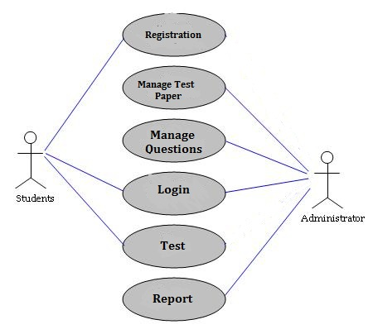

***3.2 Data Flow Diagram (0 - Level )***

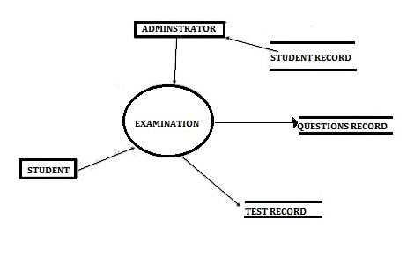

**CHAPTER-4**

**RESULT**

***4.1Database created***

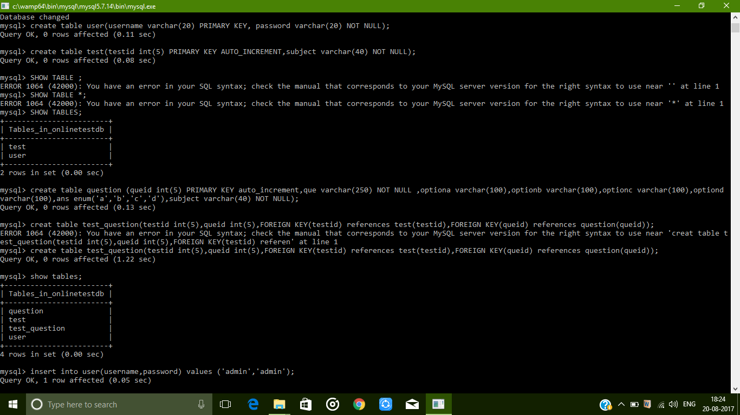

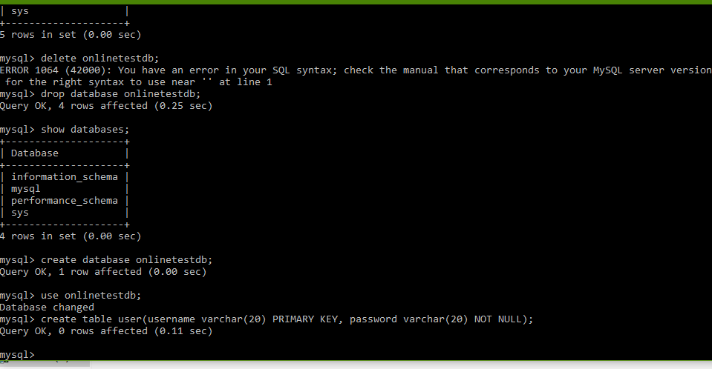

***4.2 Admin Login***

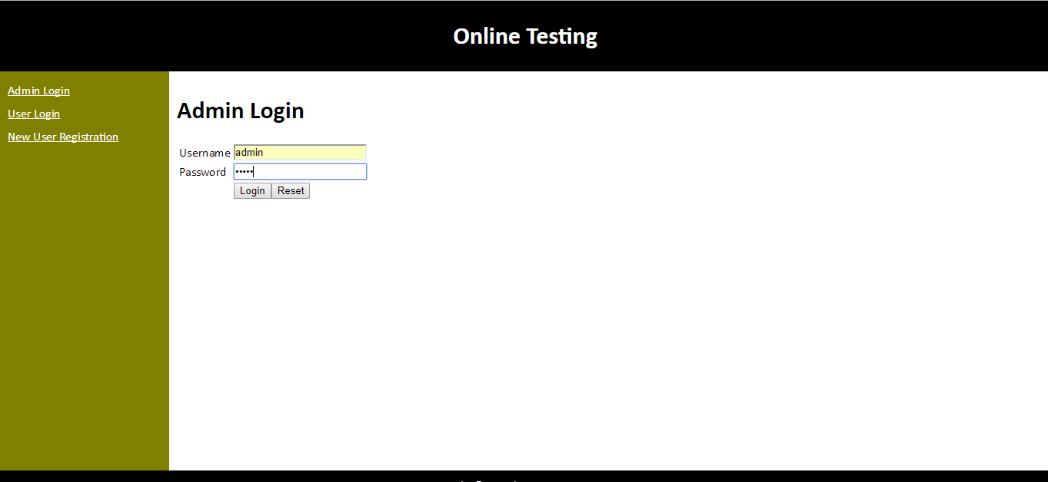

***4.3 Admin creating questions***

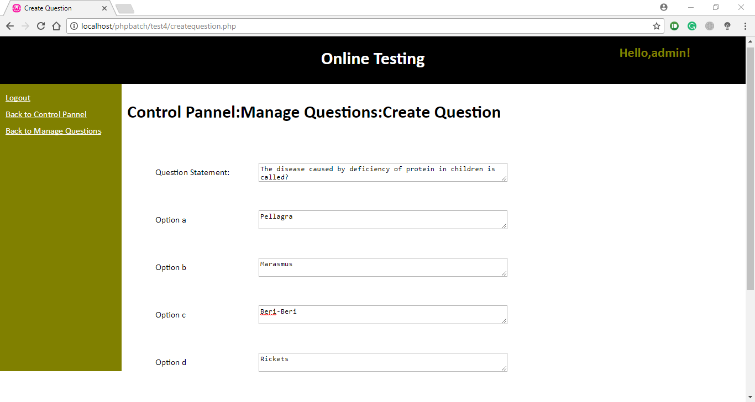

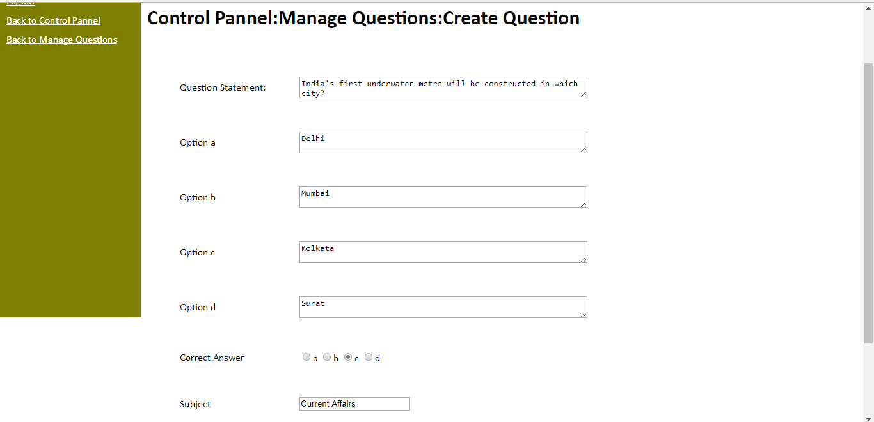

***2.4 Created Questions***

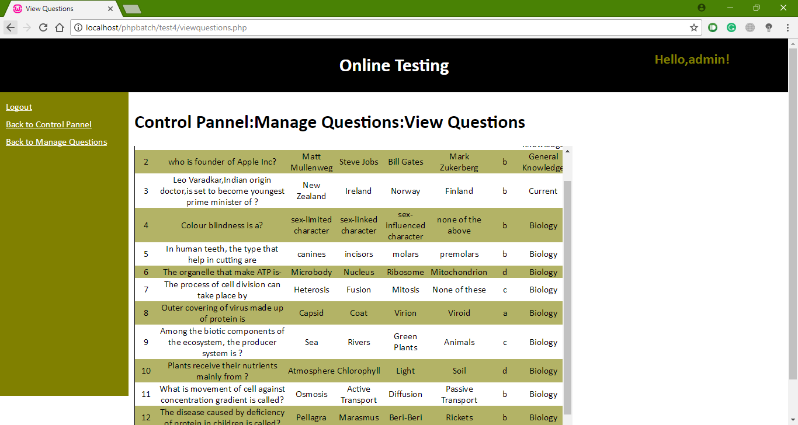

***2.5 Creating tests***

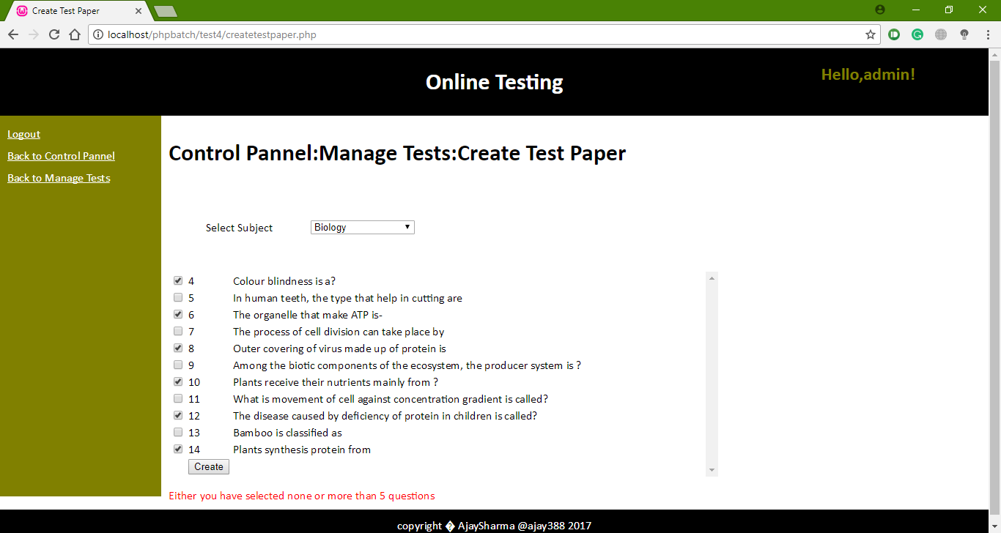

***2.6 Test paper***

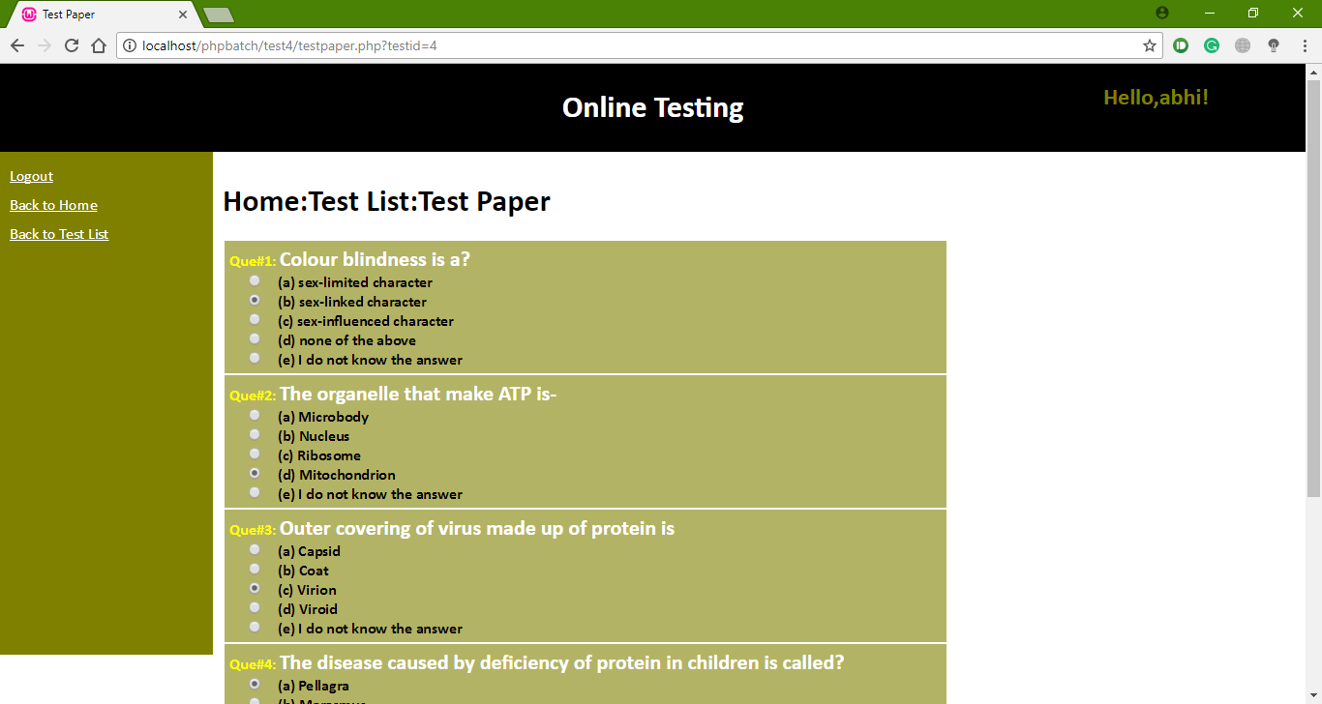

***2.7 Attempted test with result***

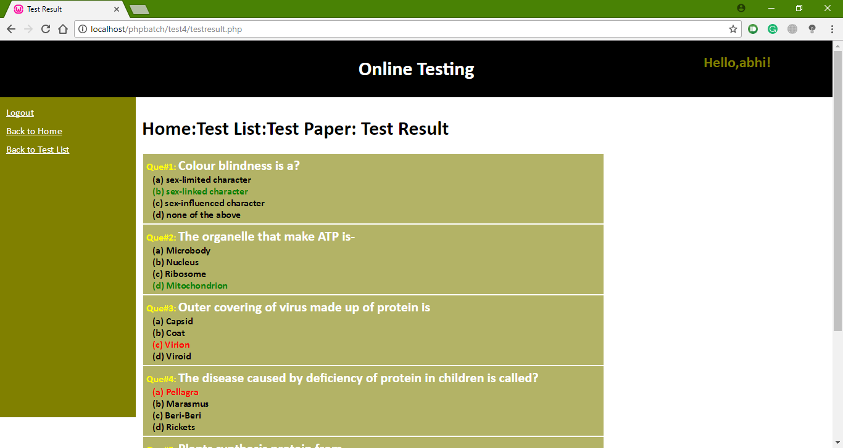

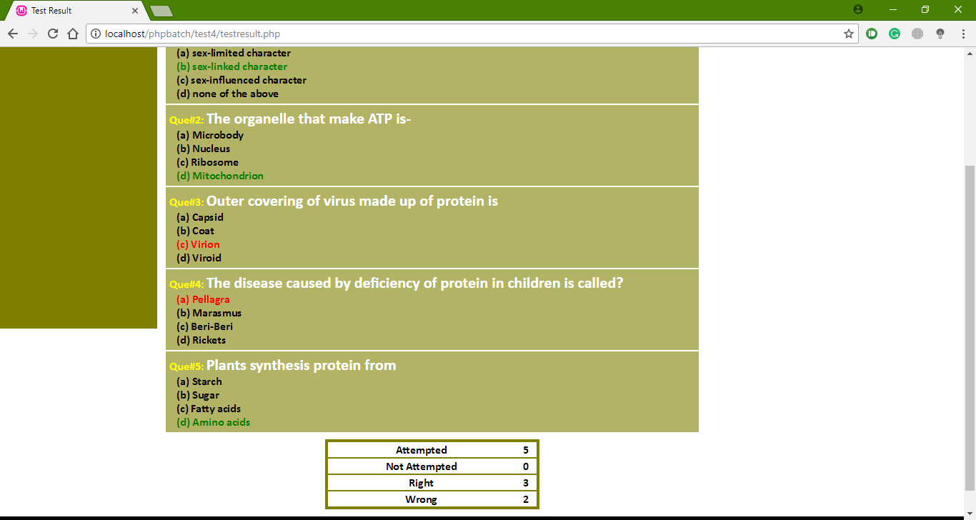

**CHAPTER-5**

**COMPARISON & ANALYSIS**

User can attempt any number of tests provided in system and check their attempted answers are write or wrong after attempting all the questions. If they give write answer then that color of that option become green otherwise it will turn into red. User can also see total number of questions attempted total number of correct answers and total number of incorrect answers.

Current system provides only multiple choices but single correct answer selection. Faculty may wish to provide multiple choices multiple selection responses.

Incase questions and/or answers need to be in graphics, current system has no provision.

**CHAPTER-6**

**CONCLUSION AND FUTURE SCAPE**

***6.1 Conclusion***

The online course and project was challenging yet satisfying experience for us as we were able to learn lot of things and gain experience in making such projects.

It was little difficult initially but after some perseverance project was made and flaws in project were removed.

This project can be very useful for various students who want to hone their knowledge and skills so that they can give various online exams.

**5.2 Future Scope**

This project would be very useful for educational institutes where regular evaluation of students’ is required. Further it can also be useful for anyone who requires feedback based on objective type responses.

**CHAPTER-7**

**REFERENCES**

1. <http://www.wampserver.com/en>
2. <https://www.udemy.com>
3. <https://www.mysql.com/>
4. <https://www.tutorialspoint.com/php/>
5. <https://worldvectorlogo.com/logo/php-1>
6. <https://commons.wikimedia.org/wiki/File:WampServer-logo.png>
7. <http://html5beginners.com/wp-content/uploads/2014/09/java.png>